

*Jr.*

The programs offered can occasionally vary depending on the coaching staff available but the primary programs include:

* Band Program (5th-8th grade boys and girls)
* Trap Program (6th-8th grade boys/girls)
* Tackle Football (6th-8th grade boys) -Fall
* Basketball (5th-8th boys/girls) -Fall/Winter
* Baseball (5th-8th grade boys) – Summer
* Fast Pitch Softball (ages 12-14 girls)-Summer
* Volleyball (4th-8th grade girls) - Spring

***Which programs are offered?***

The Jr. Knights program offers additional opportunities for our students to grow in their athleticism

within our church and schools. The Jr. Knights organization is open to all of our regional LALSAC schools, WELS congregations, and homeschooling families.

to do so in an organization that promotes Luther High School and is operated and coached by those in our church family.

While the Jr. Knights program is supported by Luther High School, it is not organized or operated by the school. It is organized by volunteer parents

Jr. Knights strives to provide an avenue for the students in our schools who want to participate in a public or community league

offered through our elementary schools (such as basketball). We combine players from our different Lutheran elementary schools and they play on a team at their grade level together facing other teams in public/community leagues.

programs offered in our Lutheran elementary schools through the La Crosse Area Lutheran Schools Athletic Conference (LALSAC). Some of these sports are not offered through LALSAC (such as tackle football) while others are in addition to a sport already

Jr. Knights is strictly a parent volunteer run organization that currently provides multiple program opportunities outside of the sports

*On behalf of the Jr Knights parent board we want to invite your participation in our programs that offer a variety of athletic and band opportunities all throughout the year.*

*Who are the Jr. Knights?*

***Do all things to the glory of God***

***1 Corithians 10:31***

**Frequently Asked Questions**

***Knights***

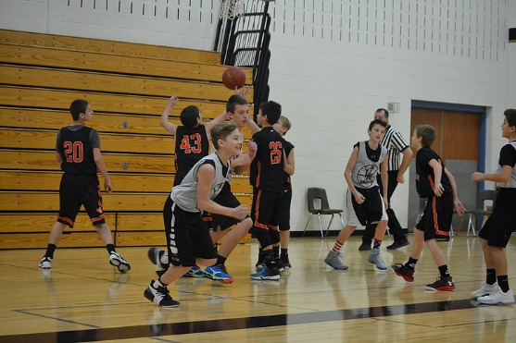

***What is the difference between this athletic program and my school sport’s program and what is the benefit to being involved?***

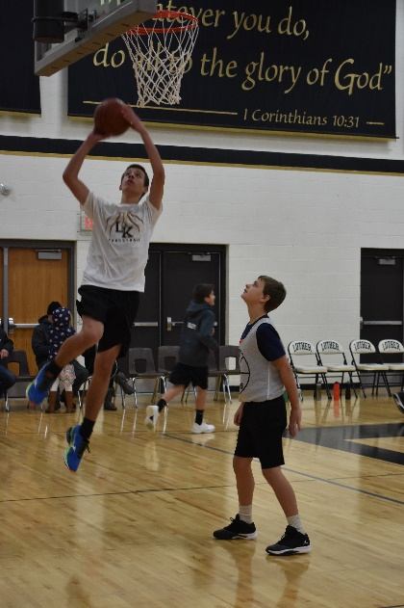

For further questions, please contact the athletic director from your school or from Luther High school.

The Jr. Knights board sends information email communication throughout the year to each school in LALSAC. Your athletic director and/or principal will be asked to pass this communication to the families in their congregations.

Once registered for a sport, you will receive direct emails from the board with any applicable information for that registered sport.

Information is also updated on our website at [www.lutherjuniorknights.com](http://www.lutherjuniorknights.com).

*Where can I find more information?*

*The Jr. Knights board uses a variety of methods to communicate about our programs.*

Registration can be done online at [www.lutherjuniorknights.com](http://www.lutherjuniorknights.com). As registration opens each season, information is sent via flyers and email to the schools and athletic directors as well as to past participants.

**Please note that registration for the fall sports of football and basketball have deadlines in early** **August**.

*Registration is often required much earlier than expected as we must submit information to the community leagues way ahead of time so they can set up the schedules.*

*How do I register for a Jr. Knights program?*

as a team. Public schools often have players working together for years before they get to high school; we are striving for that competitive edge at Luther as well. What makes the Jr. Knights program special is that we share our common faith and our coaches mentor out of their love for Christ.

Similar to LALSAC, Jr. Knights encourages that parents and players follow their school guidelines and policies in regards to conduct, academics and player/parent support of the athletic program.

often higher levels of competition outside of their school sport schedule. This is a program that is meant to complement LALSAC activities and is not meant to replace it. The time committed to Jr. Knigths is in addition to any time committed to the LALSAC sports seasons. This program is meant for athletes looking for more experience in a given sport they are interested in and not to take away from their school involvement and school spirit.

Joining athletes together that someday may play at Luther also helps the transition to the competition at the high school level

It was originally developed by some parents as an effort to connect and foster relationships between Christian young people in our different LALSAC schools. It promotes relationships in a collaborative manner, working with each other, rather than in competition against each other. These friendships can be very important in the transition from grade school to high school for students that someday may continue their Christian education at Luther High.

Jr. Knights also provides an opportunity to develop stronger athletic skills and experience through extended playing opportunities and

*For more information,*

*visit our website at www.lutherjuniorknights.com*

JrKnights basketball teams are entered into the Great Northwest Basketball League (GNBL) which is an independent public league. Tournament games are played on Saturdays for this league. Each tournament usually consists of 3 games for each team.

The girls season typically ranges from November through January and the boys from December through February. The majority of teams play during the December and January months.

Typically, the 5th and 6th grade teams will be entered to play in 3 different Saturday tournaments. The 7th and 8th grade teams may range from 4-6 Saturdays in a season. Tournaments are played at various locations, but usually within an hour of travel.

Tournament schedules are set up by the GNBL which organizes tournaments throughout the state. Season schedules start to come out in late October. To be part of the schedule, Jr Knights teams are required to be registered by the end of August.

Tournaments schedules are posted to the GNBL website at [www.gnbl.com](http://www.gnbl.com). The detailed tournament schedules get finalized and posted only 2 weeks prior to the 1st GNBL tournament of the season. As schedules become available, we do try to transfer them to the Jr Knights website.

For more information on the Great Northwest Basketball League, visit www.gnbl.com.

*What can I expect for the basketball season?*

your coach and discuss before practices are planned.  Coaches are happy to discuss and are flexible. We understand the challenges for some families with distance and schedules and your coach will work with each family if there are conflicts.  Many of our coaches are coming from long distances as well and many parents are willing to help carpool.

Please DON'T wait for a schedule to decide on the registration. By that time it may be too late to sign up. We rely on your e-mail to get you this detailed information. If you aren't sure about committing to the team that is ok. Please contact one of our board members to discuss or just register and realize that if conflicts arise in the schedule, the coaches will be willing to discuss them.

For basketball, in early October (TBA each season) we strongly encourage all participants to come to the Jr Knights parent meeting where we hand out the up to date coach and Jr Knights board members contact information and the process they use for practice scheduling and tournament information.   We do our best to update the Jr Knights Website but we do send emails to the schools several times a year with updated information.   If there are questions have your athletic director contact the Jr Knights communication lead.

Coaches for Junior Knights are volunteers. While they enjoy coaching our children they must tailor their practices in accordance with what their busy schedules will allow.  Each individual coach will determine the dates and times for his/her practices.  This of course, can vary from coach to coach and year to year.  There is NO SET SCHEDULE. The schedule will not be set up until after registrations have been submitted.

In general, the coaches will practice 1-2 times a week depending on the sport and grade level. Be aware that basketball at the 7th-8th grade level may have practices more frequently due to the competition level. Coaches will make every effort not to conflict with LALSAC practices but sometimes both practice times may fall on the same evening for some sports.  Practices usually are on later weeknight evenings or day hours on weekends and often are done at Luther High.

Every registered player should receive an e-mail from their coach or the Jr Knight board prior to their practice dates that explain the dates and times of practices they are planning.

If you have a concern or a question about the practices you are welcome to contact your coach and discuss before practices are planned.  Coaches are happy to discuss and are flexible. We understand the challenges for some families with distance and schedules and your coach will work with each family if there are conflicts.  Many of our coaches are coming from long distances as well and many parents are willing to help carpool.

* **Please DON'T wait for a schedule to decide on the registration. By that time it may be too late to sign up.** We rely on your e-mail to get you this detailed information. If you aren't sure about committing to the team that is ok. Please contact one of our board members to discuss or just register and realize that if conflicts arise in the schedule, the coaches will be willing to discuss them.
* For basketball, in early October (TBA each season) we strongly encourage all participants to **come to the Jr Knights parent meeting** where we hand out the up to date coach and Jr Knights board members contact information and the process they use for practice scheduling and tournament information.   We do our best to update the Jr Knights Website but we do send emails to the schools several times a year with updated information.   If there are questions have your Athletic Director contact the Junior Knights Communication lead.

*Who is my coach? What will the practice schedule look like?*